**Part 1 – History**

1. How many commits are there?

9

2. What is the commit message associated with the most recent commit?

Commit message :Whoops, forgot to ignore class files

3. Which commit added the basePrices static variable?

Commit id :b590e9d

Commit message :Factored prices into an array

4. How many branches are there?

4 branches exist :

* Local branch master
* Three remote branch
  + Remote/origin/HEAD
  + Remote/origin/coupon
  + remote/origin/master

5. Which is the last commit on the coupons branch?

Commit id :67ba33edfb465babbbae8d1cbe43cb4c78583cfe

Commit message :Added coupon feature

**Questions**

1. When working alone on a project, how frequently should you commit your code to a version

control system? Explain why.

While working alone, one should commit stage by stage.  
 As I am working alone, I solely will be responsible for the changes and have to ensure that each stage is working fine. If by chance the stage doesn’t work I can rollback to previous working stage easily.

2. When working in a team, how frequently should you commit your code to a version control

system? Explain why.

While working in team, one must commit only after ensuring proper working of the added change and also he/she must ensure the existing functionalities does not break down due to the change made.

Therefore commit should be done functionality by functionality. So that other team members can better understand the added functionality as it would be hard to understand everything at once.

3. Why might you create branches for your project in your version control system?

Branches are created so that we can test and verify the existing and the added changes effectively without worrying about main branch. After BVT (Build Verification Testing) of the new branch we can merge it to main branch ensuring reliability.

Output of git log:

**After Part 2:**

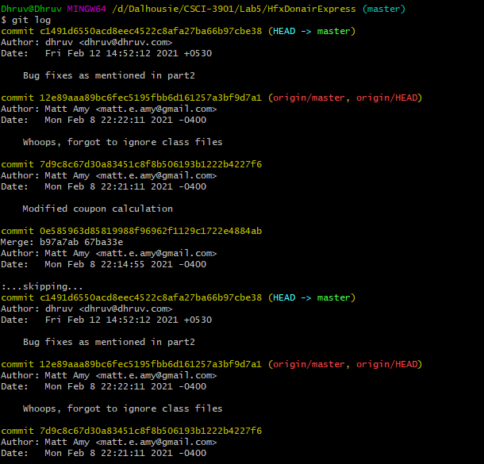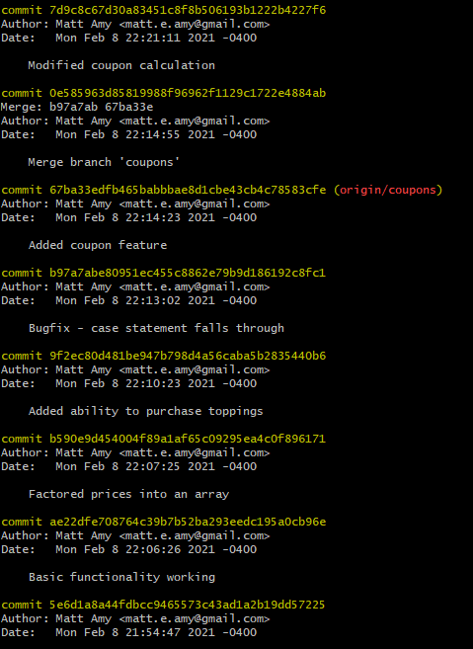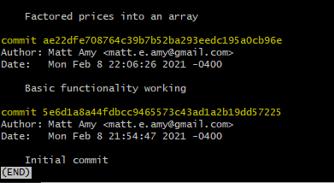

**After part 3:**

